
Self-Reflection Rubric

OBJECTIVE: Reflect on the status of key components of a multi-tiered system of supports (MTSS) within the school/district.
OUTCOME: Identify specific areas of focus which will inform prioritization, goal setting, and action planning for the coming year.

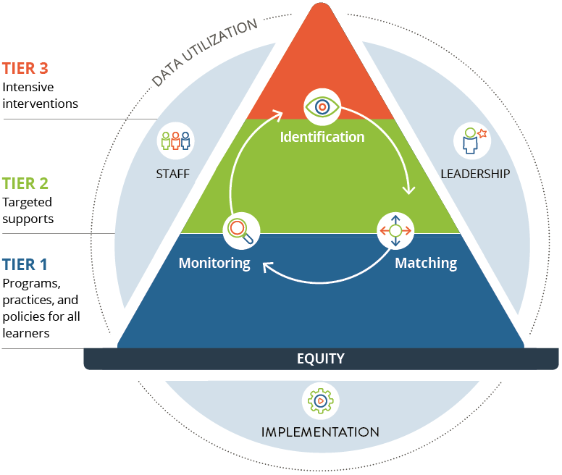
DIRECTIONS
This tool prompts a high-level reflection on the five key components of a comprehensive multi-tiered system of supports (MTSS) for social, emotional, and behavioral development including, Team, Tiered Supports, Identification, Matching & Monitoring, Drivers of Effectiveness (leadership, implementation & staff) and Data Utilization. The purpose of this tool is to guide both initial implementation and sustained use of MTSS Systems, data and practices. Administration of this tool should result in new or revised goals and related action steps. Teams are encouraged to engage with this tool to best identify areas of strength, but also areas of growth that support enhanced implementation. This tool is not meant for evaluation, but rather to prompt reflection, promote conversation and increase alignment on the current state of MTSS elements. You are encouraged to be honest in your reflections and when in doubt, err on the
lower rating. The Needs Assessment will be completed annually as part of the continuous improvement process and therefore evolution and adjustments are expected.
Because equity is the foundation of an effective MTSS, embedded in each item are equity considerations. When rating each element of the MTSS framework be sure to include the equity considerations in your rating and reflections.

Teams are encouraged to leverage the external perspective and expertise of their coach
to complete the entire self-reflection and then dive deeper into reflection on a focus area(s) of their choice.

Rating Scale
0 = Not at all or Unsure
1 = Barely, needs significant work and/or there is not currently documented evidence
2 = Somewhat, needs refinement
3 = Completely, consistently and effectively in place, just needs to be sustained

2. Tiered Supports
2a. Consistent and aligned social, emotional, and behavioral universal supports are guided by a documented framework within and across grades in ways that are developmentally appropriate and culturally affirming. Through both explicit teaching and implicit integration, all staff, within all contexts of the school environment, support the social, emotional, and behavioral development of students in ways that can be clearly articulated and/or identified by students, staff, and families.
Equity Consideration: The guiding framework is informed by the social identities, cultural practices, and values of the various groups represented in the school community. Universal supports are adaptive and responsive to the needs of all learners across different identity groups.
0  There is no clear vision or framework guiding universal social, emotional and behavioral supports for students. There is limited or inconsistent teaching and integration of such supports throughout the school/district. | 1  There is a framework and/or a somewhat of a vision guiding universal social, emotional and behavioral supports for students. There is some teaching and integration of such supports throughout the school/district. | 2  There is a documented framework guiding universal social, emotional and behavioral supports for students. Both explicit teaching and implicit integration of such supports exist in various spots throughout the school/district. |  | 3  There is a documented framework guiding universal social, emotional and behavioral supports for students. Explicit teaching and implicit integration of such supports exist throughout the entire school/district. Students, staff, and families are aware of and can identify consistent practices. The available supports meet the needs of all students.
2b. As needed, for specific students at a particular time, targeted supports (e.g., SEB skill groups, check-in/check-out) are available both inside and outside of the classroom setting. These supports are clearly documented and understood, implemented by trained staff, and properly monitored/managed.
Equity Consideration: The selection and implementation of targeted supports are responsive to the assets, cultural values, and linguistic repertoires of students. Implementation and progress monitoring
are critically analyzed through a lens of inclusive, anti-racist practices to identify and address implicit
bias and exclusionary practices.
0  Targeted supports are not available, inside or outside of the classroom for students with specific needs. | 1  Some targeted supports exist, inside or outside of the classroom, for students with specific needs. There is limited documentation and/or insufficient understanding, implementation and monitoring of these supports. | 2  Targeted supports exist, inside and outside of the classroom, for students with specific needs. There is some documentation and/or somewhat consistent understanding, implementation and monitoring of these supports. The available supports meet the needs of some students who would benefit from targeted supports. |  | 3  Targeted supports exist, inside and outside of the classroom, for students with specific needs. There is clear documentation and effective understanding, implementation and monitoring of these supports. The available supports meet the needs of all students who would benefit from targeted supports.
2c. As needed, intensive social, emotional and/or behavioral supports (e.g., 1:1 counseling, behavior support plan, referrals to outside mental health providers) are available to students with elevated needs at a particular time. These supports are clearly documented and understood, delivered by trained staff, and properly monitored/managed.
Equity Consideration: The selection and implementation of intensive supports are responsive to the assets, cultural values, and linguistic repertoires of students. Implementation and progress monitoring are critically analyzed through a lens of inclusive, anti-racist practices to identify and address implicit bias and exclusionary practices.
0  Intensive supports are not available for students with elevated needs. | 1  Limited intensive targeted supports exist for students with elevated needs. There is limited documentation and/or insufficient understanding, implementation and monitoring of these supports. |  | 2  Intensive supports exist for students with  elevated needs. There is some documentation and/or somewhat consistent understanding, implementation and monitoring of these supports. The available supports meet the needs of some students who would benefit from intensive supports. |  | 3  Intensive supports exist for students with elevated needs. There is clear documentation and effective understanding, implementation and monitoring of these supports. The available supports meet the needs of all students who would benefit from intensive supports.
NOTES

RATINGS
Focus Area | Rating

1. Team Structure
2.a Tiered Supports: Tier 1 | Rating
2.b Tiered Supports: Tier 2 Supports: Tier | Rating
2.c Tiered Supports: Tier 32erea | Rating

3. Identification, Matching & Monitoring
4.a Drivers of Effectiveness: Leaders | Rating
4.b Drivers of Effectiveness: Staff | Rating

4.c Drivers of Effectiveness: Implementation

5.a Data Utilization: Outcome Data

5.b Data Utilization: Fidelity Data

REFLECTIONS
Based on your discussion and these rubric ratings, record the following to inform your next steps.

Our greatest areas of strengths are:

The areas that show the most significant gaps are:

The areas where there are most promising opportunities for improvement are:

